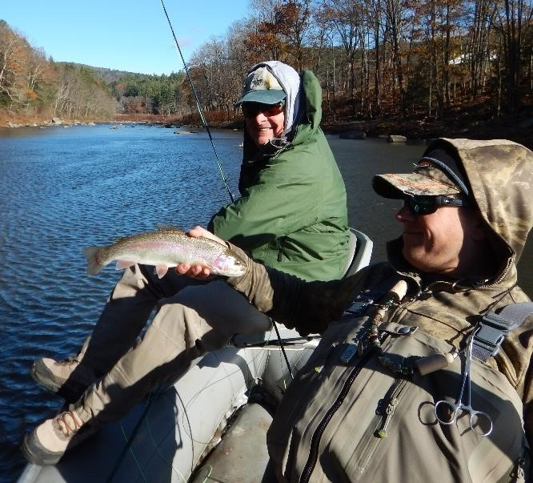
Monadnock Trout Unlimited
2018 Fall Campout
Deerfield River, Charlemont, MA
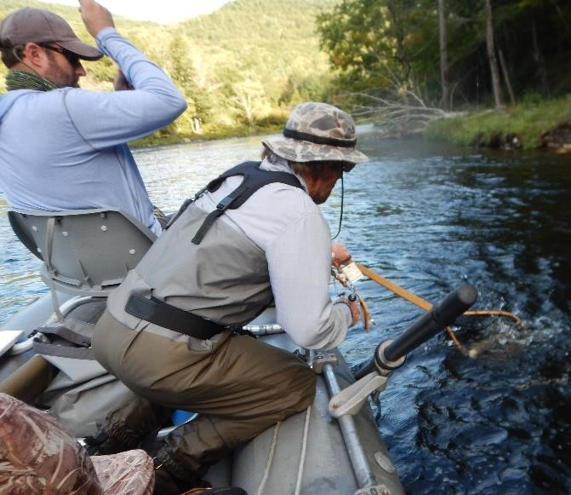
September 20-23, 2018

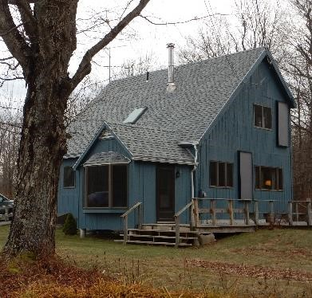
Join us this fall for a weekend of fishing and camaraderie! Fishing will be as usual on the Fife Dam stretch of the Deerfield River. Join us for a day or for the whole weekend! Stay overnight or do a day trip! Stay 1 night or 3!
Camping:
Due to scheduling and logistics issues last fall, the Mohawk State Park campground was unavailable. We were forced to use a vacation housing rental. As it turns out, this was not seen as such a bad idea, and we will be staying at the same location in Hawley, MA, just south of Route 2. (Flights End, 6 Pond Road Hawley, MA 01339)

Fishing:
A variety of fishing options are available. Wading opportunities abound on the Deerfield, and, weather cooperating, there should be dozens of accessible hot spots. Chapter members may be bringing their own drift boats, and as usual, boats have been reserved with the Harrison Brothers.

Food:
Tradition dictates that on the first night (Thursday, September 20th) members will meet at a local restaurant for dinner. This allows for latecomers, no-shows, etc. Food is provided for the Continental Breakfast and sandwiches for lunch. On Friday night, Chef Lew Derby will prepare one of his culinary masterpieces. Saturday is the same for breakfast and lunch, with whoever is available once again dining out (or taking out) on Saturday night. Sunday all members are on their own.

Rates:
Rates for accommodation will be determined by the number of attendees, but will reflect the number of nights you spend at the rental, plus a small amount for the Friday Dining Extravaganza and incidental breakfast/lunch items. Currently, these rates are $50 per night. (Note that due to previous issues, you will need to make a nonrefundable deposit of $50 by September 7, 2018, to secure your spot.)

Contact:
Interested? Contact Ed Henault for availability. (Email Ed at edhenault@yahoo.com)

